**Building a New Business: Applying the Business Canvas Model**

**Objective**: Students will apply the Business Canvas Model to a new software venture, building on the concepts learned in the course.

**Instructions:**

1. Begin by distributing the filled Business Canvas Model for a hypothetical software company (see below). Explain that this is a sample canvas that outlines the key elements of a successful software business.

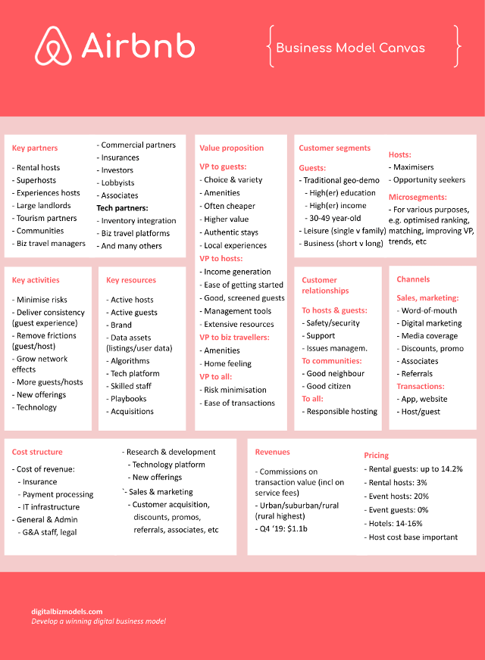

1. Divide the class into groups of 3-4 students. Each group will create a new Business Canvas Model for a software venture of their choice. Encourage students to choose a software solution that solves a real-world problem and has the potential to be commercially viable.
2. Provide each group with a large, blank Business Canvas Model poster or a digital equivalent. Instruct them to brainstorm and fill in the canvas for their chosen software venture, using the sample canvas as a reference.
3. As students work on their canvases, encourage them to consider the following aspects:

a. Value Proposition: What problem does the software solve, and how does it create value for customers?

b. Customer Segments: Who are the target customers, and what are their needs, preferences, and pain points?

c. Channels: How will the software be distributed and marketed to reach the target customers?

d. Customer Relationships: What kind of relationship will the software company have with its customers?

e. Revenue Streams: How will the software company generate revenue?

f. Key Resources: What resources (e.g., personnel, technology, infrastructure) will the software company need to create and deliver the software?

g. Key Activities: What activities (e.g., development, marketing, sales) will the software company need to perform to create and deliver the software?

h. Key Partnerships: What partnerships (e.g., with suppliers, distributors, complementary service providers) will the software company need to establish?

i. Cost Structure: What are the estimated costs for developing, marketing, and delivering the software?

1. Once each group has completed their Business Canvas Model, ask them to present it to the class. Encourage feedback and questions from their peers, and provide guidance and feedback as needed.
2. Finally, have each group reflect on their experience creating the Business Canvas Model. Ask them to consider what they learned, what challenges they faced, and how they might apply the Business Canvas Model to future software ventures.

**Assessment:**

* Group presentation and participation (40%)
* Completeness and clarity of the Business Canvas Model (30%)
* Originality and creativity of the software venture (30%)